Wednesday 20th April,

Homework and spelling support

Dear Parents and Carers,

We are excited to share a new programme that we have invested in to support the teaching of spelling in all year groups.

Spelling Shed is a scheme designed for pupils to practise their weekly spellings online via the use of the web link https://play.edshed.com/en-gb/ which is free of charge or via the Spelling Shed App (there is a small charge for the app, but you will not need to pay the subscription fee). The programme follows a game-like format which aims to build your child’s confidence in spelling. The game gives four different degrees of support in the form of difficulty modes; Easy, Medium, Hard and Extreme. Higher levels allow a higher score to be achieved, but children can practise as much as they like on lower levels before trying to gain high scores. The scores achieved give a league position and each class has its own league position within a school league and our world league.

Every Monday, your child will be set a spelling assignment linked to the spelling rule and word list they are learning in class that week. In addition, the children will also be able to access National Curriculum year group spelling list each week. As with reading and times table practise, we will be encouraging the children to login and practise their spellings for around fifteen minutes three times a week.

In class this week, your child will be given their login and password which will be kept in their planner. They will also be shown how to log in and access the different activities available. Please find the attached parent guide for more information on supporting your child to use Spelling Shed.

As a school, we hope this new programme helps to engage children and build their confidence in spelling.

To ensure we are promoting the use of Edshed, we have updated the information around homework requirements for the summer term.

Please refer to the table over the page to check the requirements for your child’s year group.

 | YEAR 3 | YEAR 4 | YEAR 5
Reading | Approx. 15 mins  5x per week | Approx. 15 mins  5x per week | Approx. 15 mins  5x per week
Times table practise using TT Rockstars | Approx. 15 mins  3x per week | Approx. 15 mins  3x per week | Approx. 15 mins  3x per week
Spelling practise using Edshed | Approx. 15 mins  3x per week | Approx. 15 mins  3x per week | Approx. 15 mins  3x per week
Additional homework | 4 optional tasks sent home at the beginning of the half term that your child may choose to complete.  These tasks will cover a range of subjects and will contain instructions of where to complete the work and when to hand the work in. |  | One homework task per week to complete.  These tasks will cover a range of subjects and will contain instructions of where to complete the work and when to hand the work in.

 | YEAR 6
Reading | Approx. 15 mins  5x per week
Times table practise using TT Rockstars | Approx. 15 mins  3x per week
Spelling practise using Edshed | Approx. 15 mins  3x per week
Additional homework | Children to continue with CGP work books.  Maths - handed out on a Monday, due in on a Thursday Grammar - handed out on Thursday, due in on Monday.  Creative Curriculum task once a half term

Kind regards,
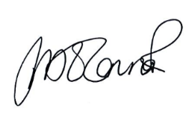
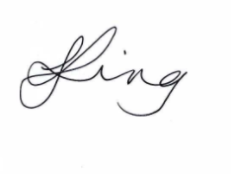

Jackie king and Pip O’Connor
Co-Head Teachers

